**ASSIGNMENT-46**

1. Section-1 – Code saved as **SparkAssignment46-1.scala** in GitHub link

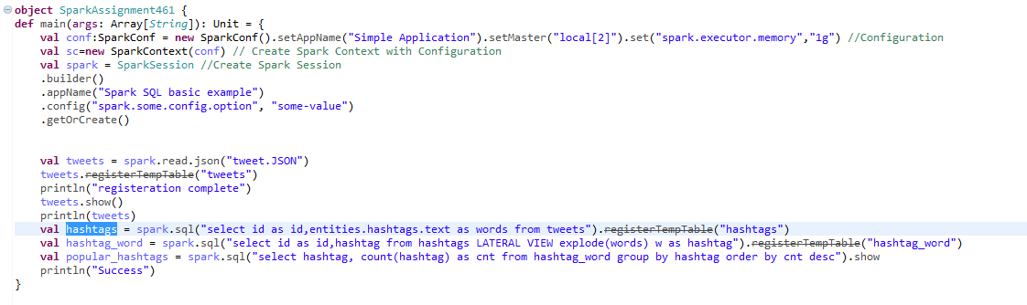

**Output:**



1. Section-2 – Code saved as **SparkAssignment46-2.scala** in GitHub link

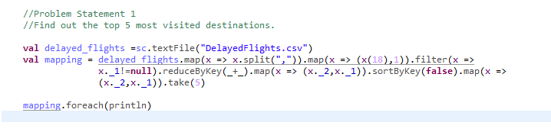

Usage of map, reduceByKey and sortByKey to get the desired results.

**Output**

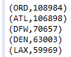

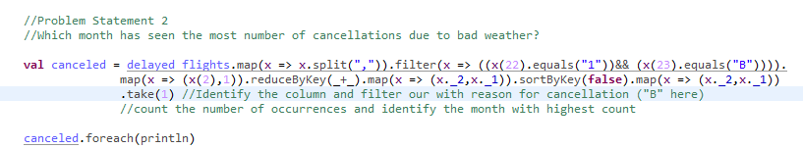

**Output**

December month with 250 Cancellation



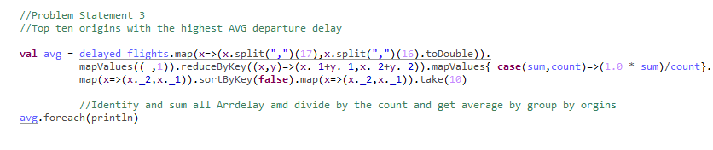

**Output**

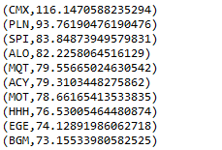

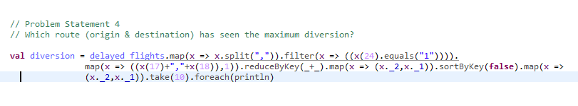

**Output**

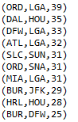

1. Section-1